Project on

**DNS and DHCP Server Administration**

**on CentOS 9**

Prepared by: Guided by:

Anmol Baghel Zakir Hussain

**TABLE OF CONTENTS**

**S no. Title Page no.**

1. Objective 3
2. Real-Time Scenario 4
3. Introduction to DNS 6
4. Introduction to DHCP 7
5. VM Installation and Setup 8
6. Implementation Steps 11
7. Conclusion 16

**OBJECTIVE:**

This project aims to understand the fundamentals of DNS and DHCP services within a CentOS 9 environment, demonstrating the processes involved in creating and managing network services through effective server administration.

This includes establishing a comprehensive infrastructure by provisioning essential components such as DNS (BIND) and DHCP (ISC DHCP) servers and the necessary administrative commands for daily operations.

Additionally, the project encompasses the installation and configuration of both DNS and DHCP services tailored to client needs, as well as performing essential system administrative tasks.

Key activities also involve verifying server functionality through testing and troubleshooting methods to ensure optimal performance.

This project aims to provide a hands-on approach to managing and optimizing DNS and DHCP server administration tasks on CentOS 9.

**REAL-TIME SCENARIO**

**Company Background:**

ABCD Marketing Company is a mid-sized marketing firm founded in 2010 by a group of entrepreneurs with a passion for innovative marketing strategies. The company has grown rapidly over the years, with a current workforce of 200 employees across three offices in the United States. ABCD Marketing Company specializes in providing digital marketing services, including social media management, content creation, and search engine optimization (SEO) to a diverse range of clients. However, the rapid growth and lack of centralized network management have led to a complex and inefficient network infrastructure.

**Current Scenario:**

ABCD Marketing Company is currently facing a critical issue with its network infrastructure. The company's network administrator is struggling to manage the IP addresses and domain name resolution for internal services and devices. The current setup is decentralized, with multiple DHCP servers and DNS servers scattered across the three office locations. This has resulted in:

* IP address conflicts and duplication
* Inefficient domain name resolution, leading to slow network performance
* Difficulty in tracking and managing devices on the network
* Inability to implement a centralized network management system

**Problem Statement:**

The network administrator at ABCD Marketing Company needs to design and implement a centralized solution for managing IP addresses and ensuring efficient domain name resolution for internal services and devices. The solution must be scalable, secure, and easy to manage, with the ability to integrate with existing network infrastructure.

**Requirements:**

* Implement a centralized DNS solution to manage domain name resolution for internal services and devices
* Configure a DHCP server to assign IP addresses dynamically to devices on the network
* Ensure efficient network performance and minimize IP address conflicts
* Implement a centralized network management system to track and manage devices on the network
* Ensure scalability and security of the solution to support future growth and expansion

By addressing this, ABCD Marketing Company can improve its network infrastructure, increase efficiency, and reduce costs associated with network management and maintenance.

**INTRODUCTION TO DNS**

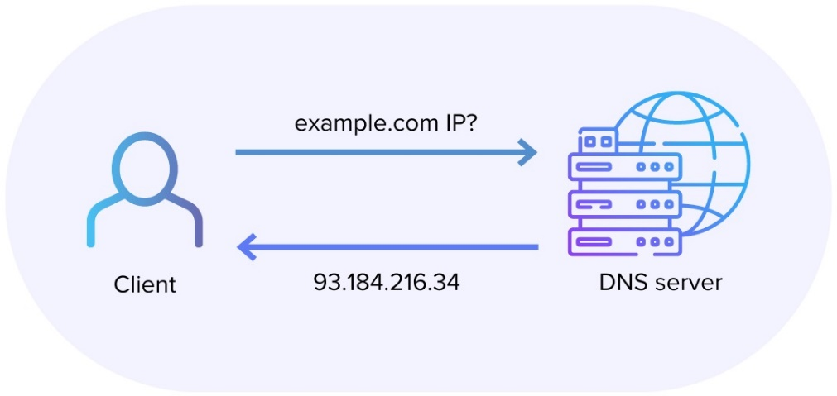

**DNS (Domain Name System)**

The Domain Name System (DNS) is a critical component of the internet infrastructure that enables users to access websites and online resources using easy-to-remember domain names instead of difficult-to-remember IP addresses. DNS is a decentralized system that translates human-readable domain names into IP addresses that computers can understand.

**How DNS Works:**

1. A user types a domain name into their web browser (e.g., www.example.com).
2. The browser sends a request to a DNS resolver (usually provided by the operating system or internet service provider).
3. The DNS resolver queries a DNS server (usually provided by the internet service provider or a public DNS service) to resolve the domain name to an IP address.
4. The DNS server responds with the IP address associated with the domain name.
5. The browser uses the IP address to connect to the website or online resource.

**INTRODUCTION TO DHCP**

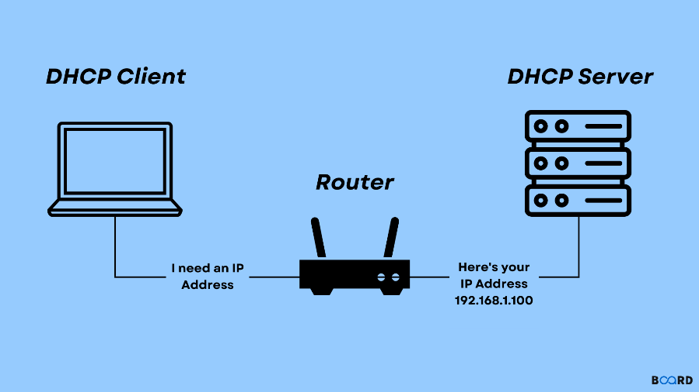

**DHCP (Dynamic Host Configuration Protocol)**

The Dynamic Host Configuration Protocol (DHCP) is a network protocol that enables devices on a network to automatically obtain IP addresses and other network settings. DHCP allows devices to dynamically request and receive IP addresses, eliminating the need for manual IP address configuration.

**How DHCP Works:**

1. A device (e.g., a laptop or smartphone) connects to a network.
2. The device sends a DHCP request to the DHCP server on the network.
3. The DHCP server responds with an available IP address and other network settings (e.g., subnet mask, default gateway, and DNS server addresses).
4. The device configures its network settings using the provided information.
5. The device can now communicate with other devices on the network and access online resources.

In the context of ABCD Marketing Company, implementing a centralized DNS and DHCP solution will improve network efficiency, reduce IP address conflicts, and enable easier management of devices on the network.

**VM INSTALLATION AND SETUP**

Step 1: Download the CentOS ISO

* Visit the official CentOS website ([www.centos.org](http://www.centos.org)) and download the latest version of CentOS (e.g., CentOS 9) in ISO format.
* Ensure you select the appropriate architecture (32-bit or 64-bit) that corresponds with your system.

Step 2: Create a New Virtual Machine in VirtualBox

* Launch Oracle VirtualBox and click on "New" to initiate the creation of a new virtual machine.
* Provide a name for your virtual machine (e.g., "CentOS 9") and set the type to "Linux."
* Choose "Linux(64-bit)" as the version and click "Next."
* Allocate a minimum of 2048 MB of RAM and proceed by clicking "Next."
* Select "Create a virtual hard disk now" and follow the prompts to set up a 20 GB virtual hard disk.
* Click "Create" to finalize the virtual machine setup.

Step 3: Configure Virtual Machine Settings

* Click on the virtual machine and select "Settings."
* Under the "Storage" tab, click on the empty CD/DVD drive and then the CD/DVD icon to locate the CentOS ISO file.
* Choose the ISO file and click "OK.".

Step 4: Start the Virtual Machine and Begin the Installation

* Click "Start" to power on the virtual machine.
* The CentOS installation wizard will load. Choose your preferred language and click "Continue."
* Select "Install CentOS 9" and click "Continue."
* Accept the license agreement and proceed by clicking "Continue."
* Choose the installation destination (e.g., the 20 GB virtual hard disk) and click "Continue."
* Configure the network settings (including IP address, subnet mask, gateway, and DNS servers) and click "Continue."
* Set the root password, optionally create a user account, and click "Continue."
* Review the installation summary and click "Begin Installation."

Step 5: Complete the Installation

* The installation will take approximately 10-15 minutes to finish.
* Once completed, click "Reboot" to restart the virtual machine.
* Remove the CentOS ISO from the virtual machine’s CD/DVD drive by selecting "Devices" > "Optical Drives" > "Remove disk from virtual drive."
* The virtual machine will boot into the CentOS GUI.

Step 6: Initial System Configuration

* Log in using either the root password or the user account created during the installation.
* Configure the system date, time, and set the correct timezone.
* Update the system by running the command “sudo dnf update” in the terminal.

IMPLEMENTATION STEPS:

**DNS Server (using BIND)**

**Install BIND (DNS Server):**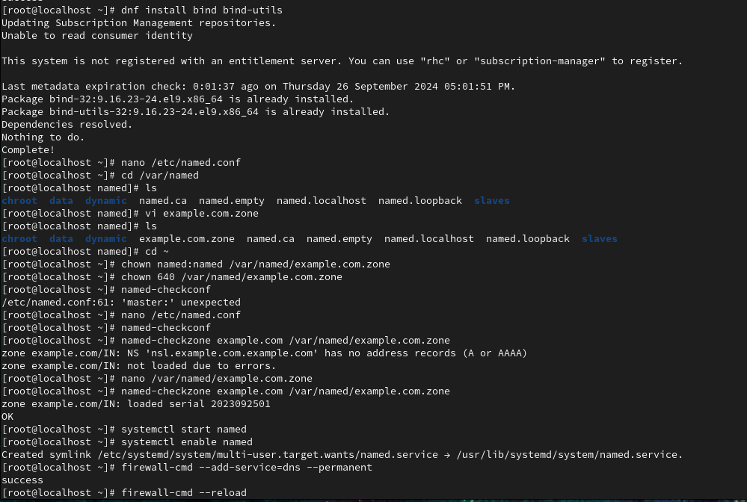



Add Zone information of your Domain:

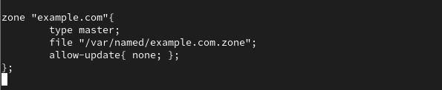

Change Ownership and Permission of “example.com”:



**Adding this content to the Zone File:**

**Now, we have to edit the zone file named “example.com.zone” with the content shown in the below image.**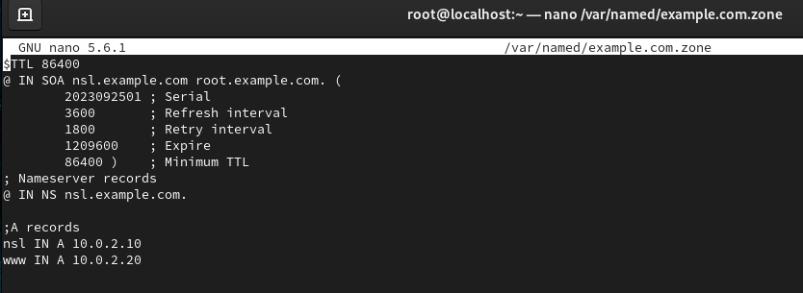



**Start and enable BIND service:**



**Configure Firewall to allow DNS traffic:**



**Test DNS queries:**

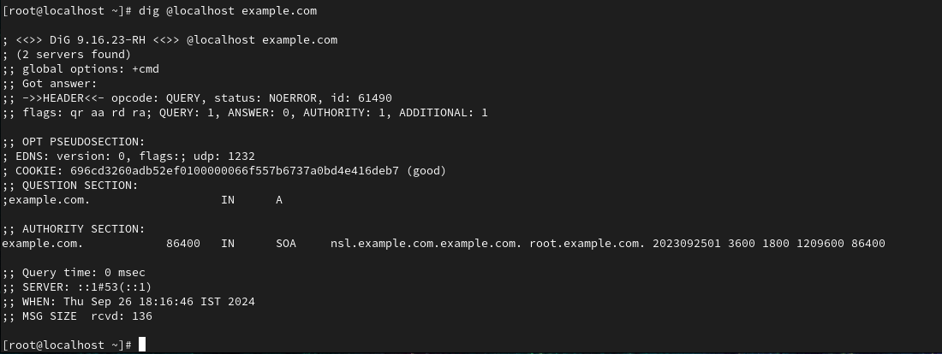

**DHCP Server (using ISC DHCP)**

**Install DHCP server:**

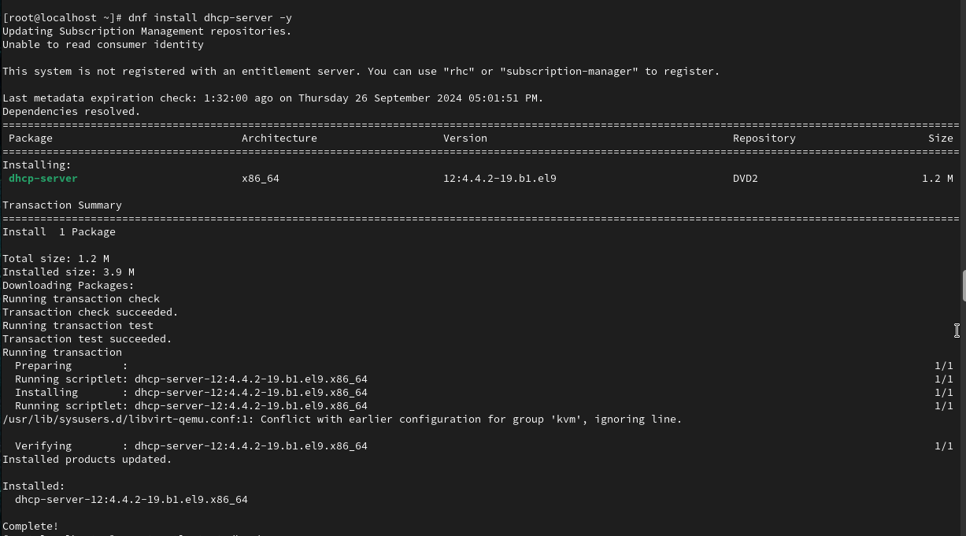

**Edit Configuration File:**

Edit the “/etc/dhcp/dhcpd.conf” file with the below configuration.

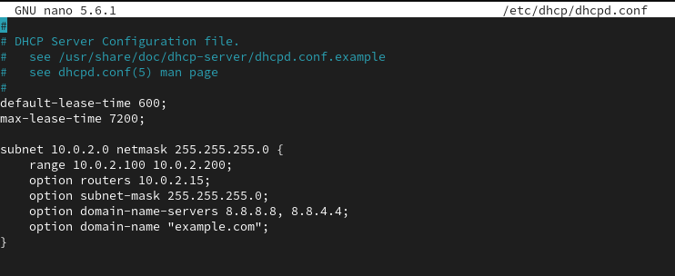

Network Interface Configuration: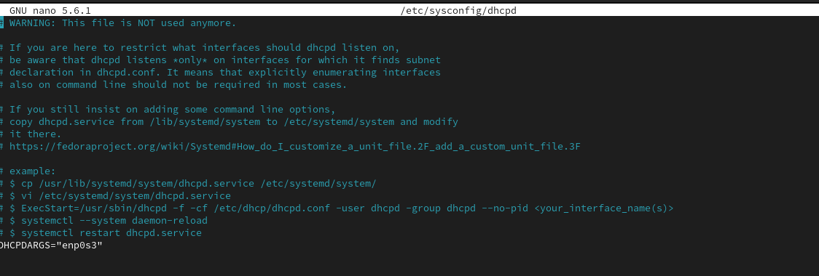

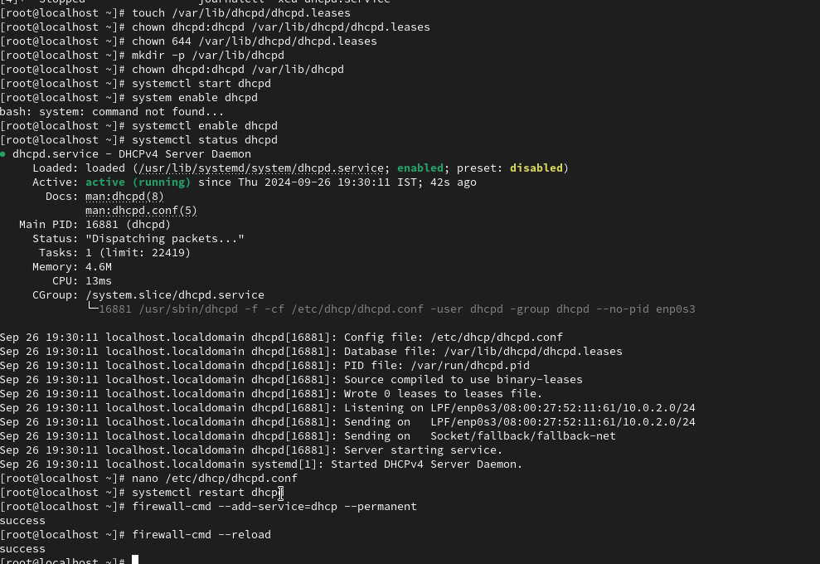

**Start and Enable DHCP:**  

Open Firewall for DHCP:



**Test DHCP Lease:**

**Use a client machine to request a DHCP lease**:

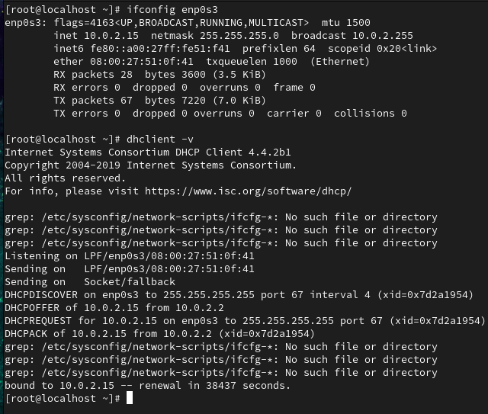

**CONCLUSION**

This documentation provides a structured approach to setting up and administering DNS and DHCP servers on CentOS 9. By following the outlined steps, administrators can ensure proper configuration and functionality of these essential services. Regular monitoring and management will help maintain network integrity and reliability.

The company's decentralized network infrastructure led to IP address conflicts, inefficient domain name resolution, and difficulties in managing devices on the network, resulting in network inefficiencies, increased costs, and device management challenges.

For further enhancement, consider implementing security measures such as access control and logging, ensuring a secure and efficient network environment.

ABCD Marketing Company's decentralized network infrastructure is causing IP address conflicts, inefficient domain name resolution, and device management issues. To address this, a centralized DNS and DHCP solution is needed to manage IP addresses and ensure efficient domain name resolution.

By implementing a centralized DNS and DHCP solution, ABCD Marketing Company can improve its network infrastructure, increase efficiency, and reduce costs associated with network management and maintenance. The solution will also enable the company to better manage its devices, reduce IP address conflicts, and improve overall network performance.